Beta Distributions

Oliver

## Beta

We can use the base plot functions in R to create a plot of the pdf for a beta random variable $X$ with parameters $α$ and $β$. Note that R defines $α=$**shape11** and $β=$**shape12**.

x <- seq(0, 1, by=0.001)  
 plot(x, dbeta(x, shape1=0.5, shape2=0.5), lty=1, col=1, type="l", xlab="x", ylab="f(x)", ylim=c(0,3))  
 lines(x, dbeta(x, shape1=1, shape2=0.5), lty=2, col=2)  
 lines(x, dbeta(x, shape1=2, shape2=0.5), lty=3, col=3)  
 lines(x, dbeta(x, shape1=0.5, shape2=1), lty=4, col=4)  
 lines(x, dbeta(x, shape1=1, shape2=1), lty=5, col=5)  
 lines(x, dbeta(x, shape1=2, shape2=1), lty=6, col=6)  
 lines(x, dbeta(x, shape1=0.5, shape2=2), lty=7, col=7)  
 lines(x, dbeta(x, shape1=1, shape2=2), lty=8, col=8)  
 lines(x, dbeta(x, shape1=2, shape2=2), lty=9, col=9)

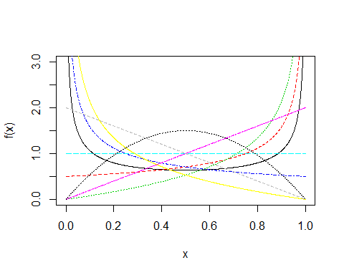

The CDF may be plotted analogously.

x <- seq(0, 1, by=0.001)  
 plot(x, pbeta(x, shape1=0.5, shape2=0.5), lty=1, col=1, type="l", xlab="x", ylab="F(x)")  
 lines(x, pbeta(x, shape1=1, shape2=0.5), lty=2, col=2)  
 lines(x, pbeta(x, shape1=2, shape2=0.5), lty=3, col=3)  
 lines(x, pbeta(x, shape1=0.5, shape2=1), lty=4, col=4)  
 lines(x, pbeta(x, shape1=1, shape2=1), lty=5, col=5)  
 lines(x, pbeta(x, shape1=2, shape2=1), lty=6, col=6)  
 lines(x, pbeta(x, shape1=0.5, shape2=2), lty=7, col=7)  
 lines(x, pbeta(x, shape1=1, shape2=2), lty=8, col=8)  
 lines(x, pbeta(x, shape1=2, shape2=2), lty=9, col=9)

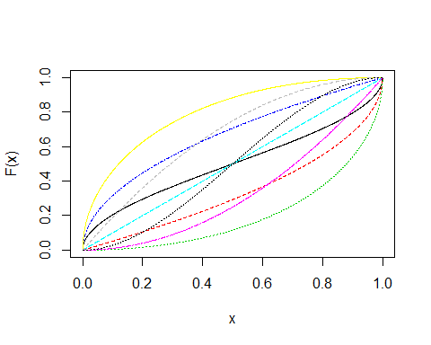

### Uniform

The special case of the beta(1,1) is actually a U(0,1). Interesting, but not very helpful.

x <- seq(0, 1, by=0.001)  
 plot(x, dbeta(x, shape1=1, shape2=1), lty=2, col=2, type="l", xlab="x", ylab="f(x)", ylim=c(-0.1,1.1))  
 lines(x, dunif(x, 0, 1), lty=3, col=3)

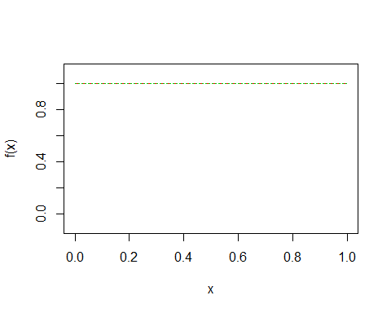

plot(x, pbeta(x, shape1=1, shape2=1), lty=2, col=2, type="l", xlab="x", ylab="F(x)")  
 lines(x, punif(x, 0, 1), lty=3, col=3)

